Lab Assignment 4

Chaudhary Hamdan

1905387

Date: 04-02-2022

Question: Take 5 User Bases, 3 Data Centers.

Change Service Broker Policy and Load Balancing Policy.

Find Response times and detailed output.

Draw graph of all 9 response times.

Screenshots:

Closest Data Center -> Round Robbin:

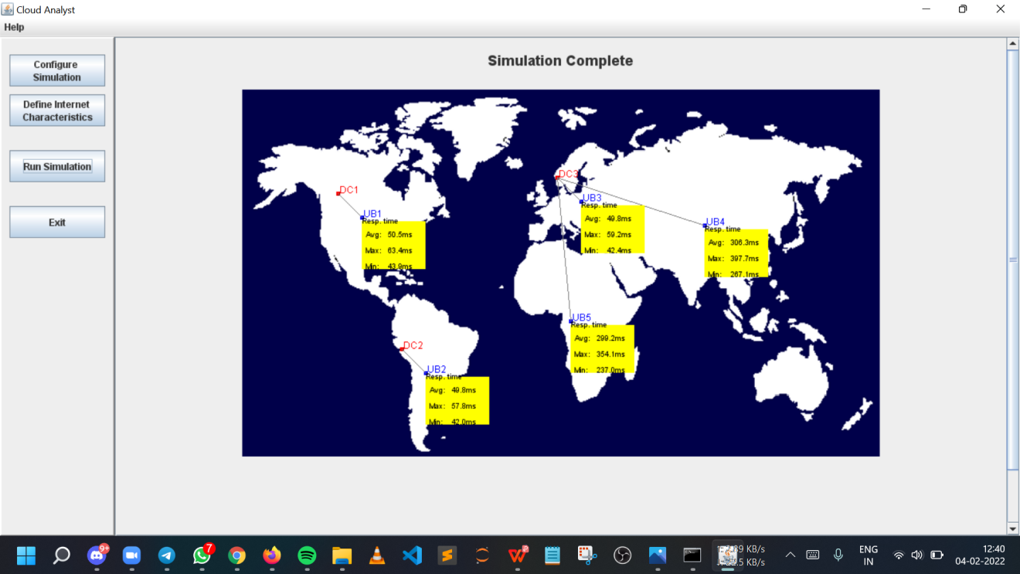

Closest Data Center -> Equally SpreadCurrent Execution Load:

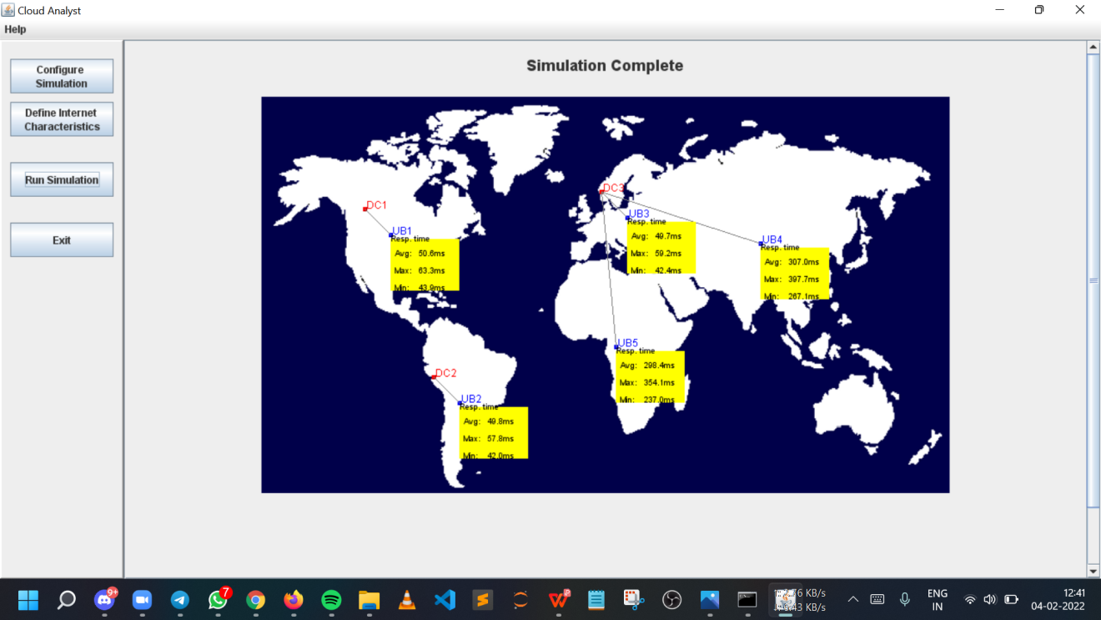

Closest Data Center -> Throttled:

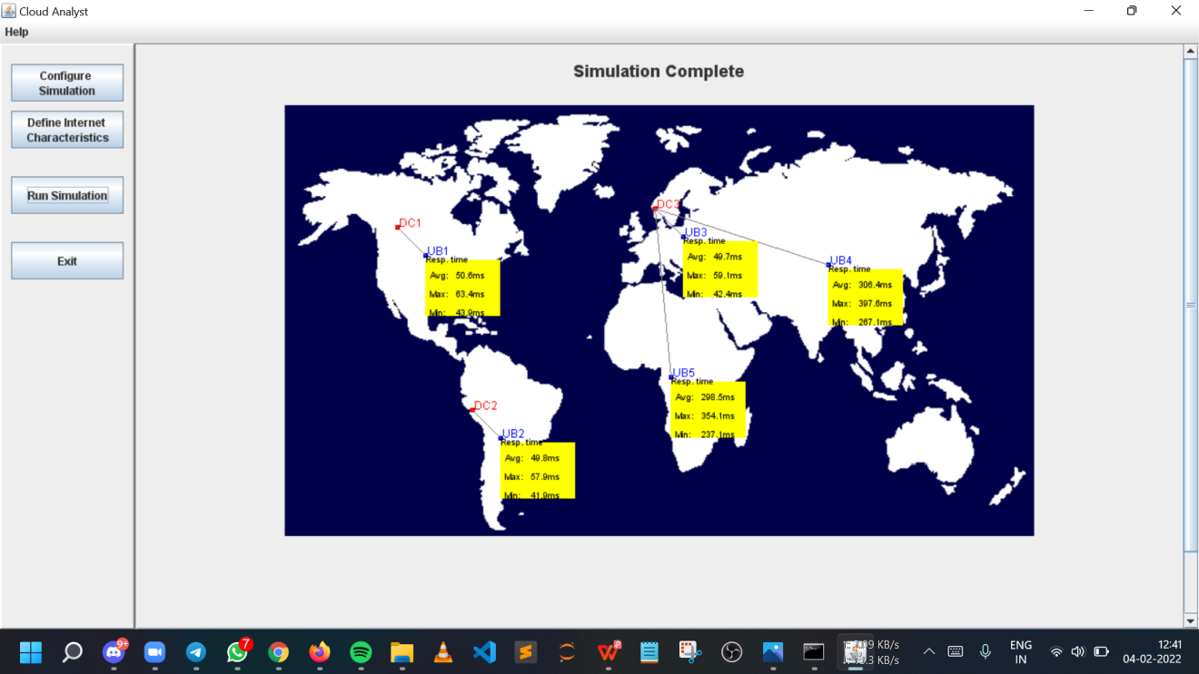

Optimise Response Time -> Round Robbin:

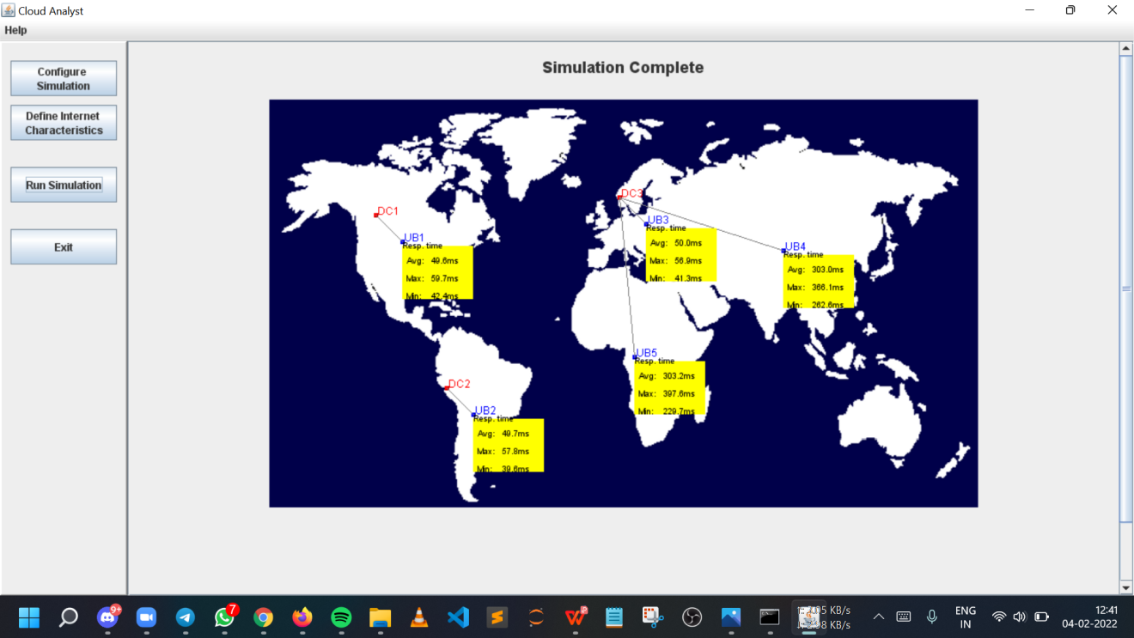

Optimise Response Time -> Equally SpreadCurrent Execution Load:

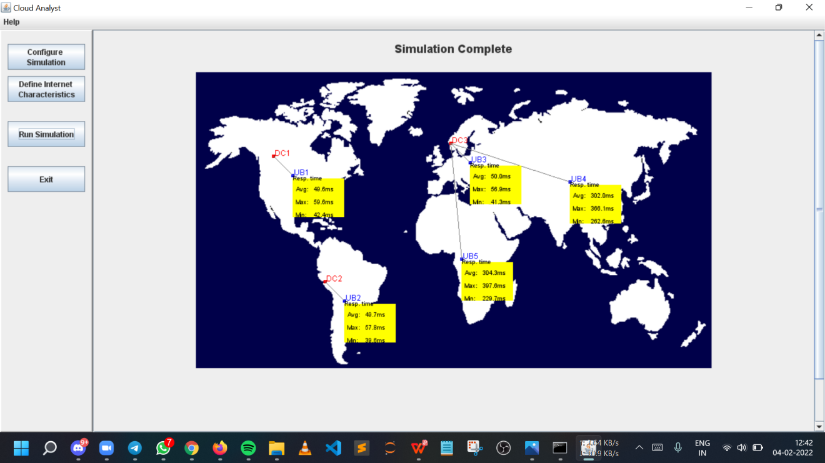

Optimise Response Time -> Throttled:

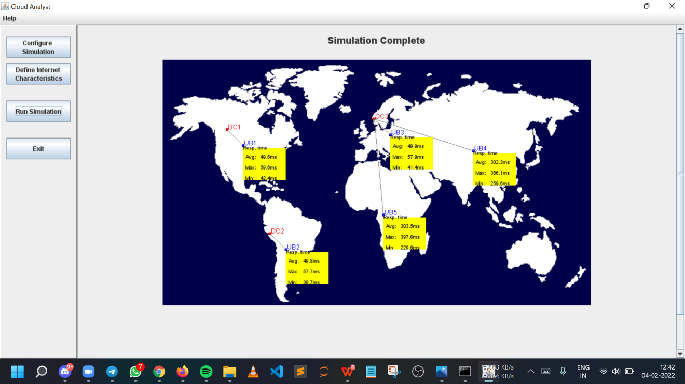

Reconfigure Dynamically with L -> Round Robbin:

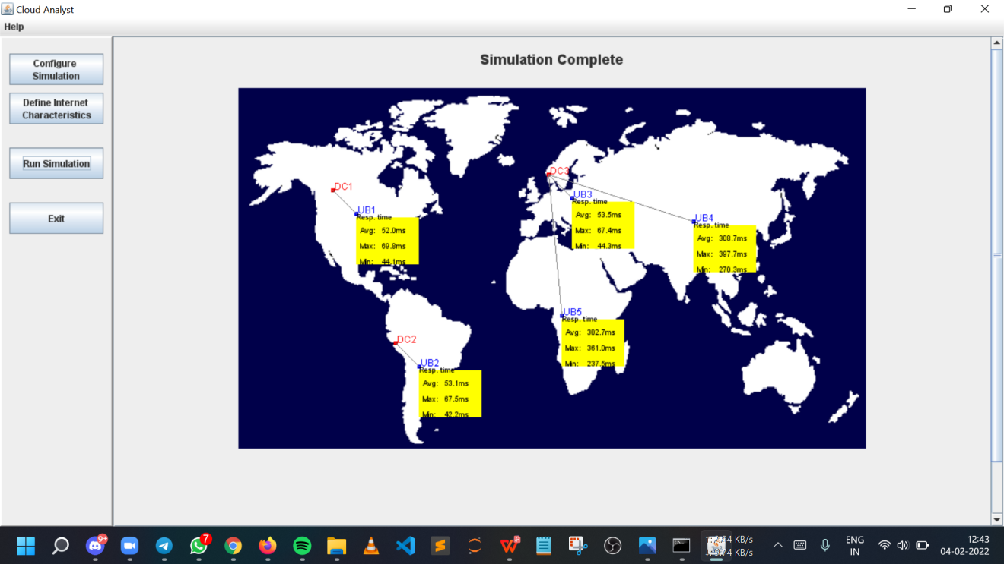

Reconfigure Dynamically with L -> Equally SpreadCurrent Execution Load:

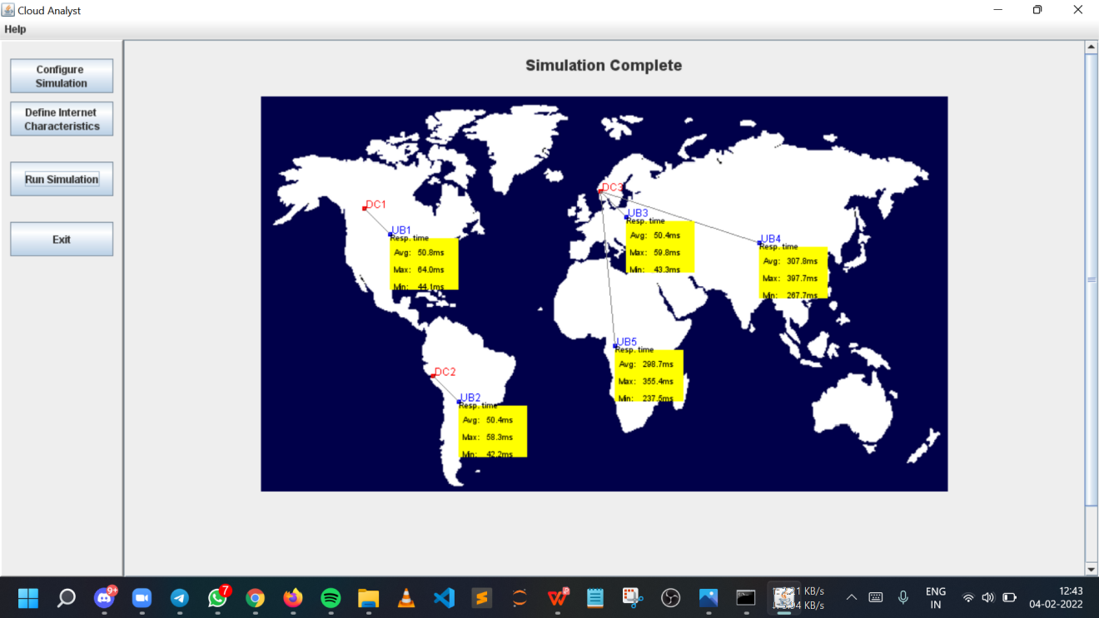

Reconfigure Dynamically with L -> Throttled:

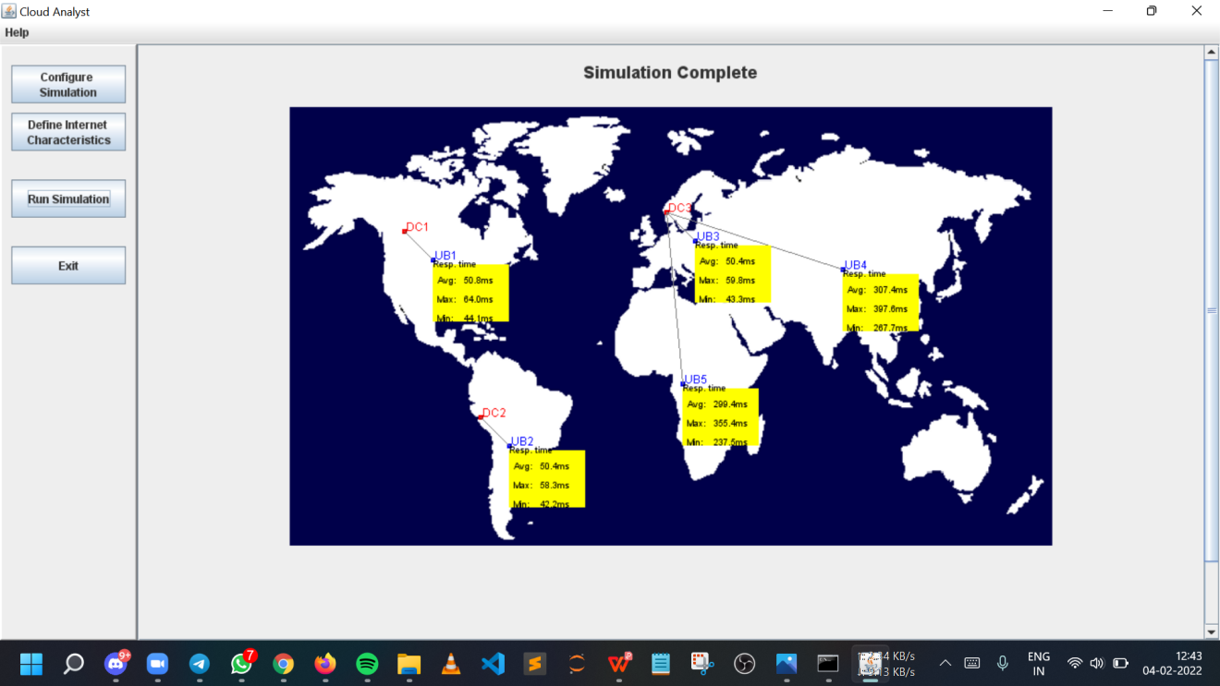

PDFs of all detailed results will be attached

in the following pages.